**Lesson 4 – Unit 1 GCSE English Language Revision**

|  |
| --- |
| Learning Objective –  **Can I identify and comment on the presentational features of a non-fiction text? (Key words: Headline, Sub-headline, Image, Caption)** |

**We are going to work this week on the second kind of skill you’ll have to show at GCSE – the ability to analyse the presentational features of a text, and to connect them to the content, purpose, audience etc. of the text itself.**

**Question 2** refers to the second of the sources, called Item 2, and will test your ability to ***understand and interpret*** presentational features such as headline, sub-headline, pictures and captions from the source text. **8 marks**

**Match the headline to the picture!**

1. **Scientists on brink of HIV cure**
2. **New build house prices rise by 12pc**
3. **Tobacco display ban in large shops comes into force**
4. **Is there really a north-south water taste divide?**
5. **WWI prisoner of war postcard found**
6. **Children and apps: Should we fear the iNanny?**

**[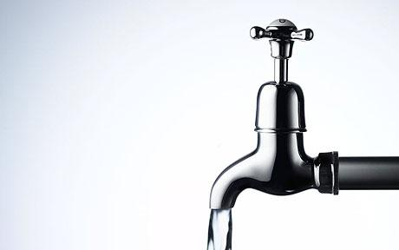](http://cdn.zmescience.com/wp-content/uploads/2012/07/tap.jpg)**

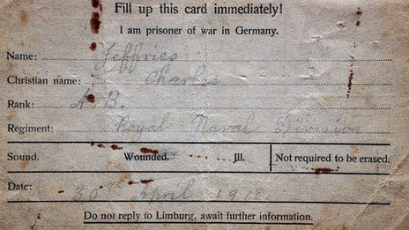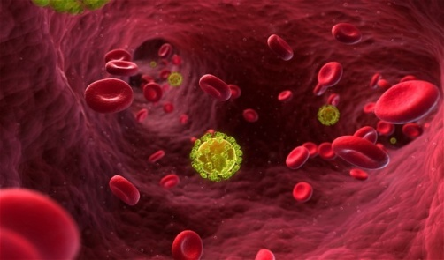

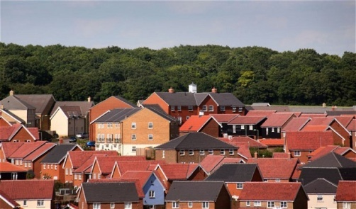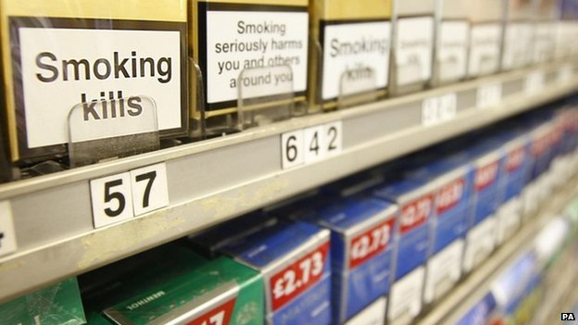

1. **Earth’s core far hotter than thought**
2. **Measles: 'greater risk of infection' in private schools**
3. **John Hannah on the best cycling routes**
4. **Meet the women doing ‘men’s work’**
5. **University reputations: will teachers pay the price?**
6. **Katherine Jenkins ran the marathon and still looked good. So what?**



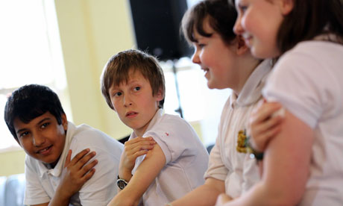

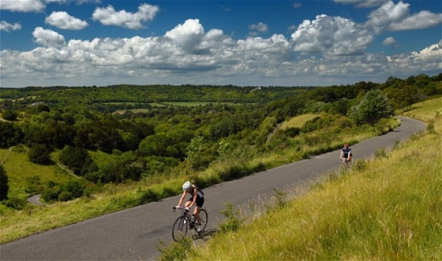



|  |  |  |  |
| --- | --- | --- | --- |
|  | **Headline** | **Image** | **Caption** |
| **Features**  ***Do they have typical features?*** |  |  |  |
| **Functions**  ***What are they for?*** |  |  |  |



**IN PAIRS**

**Which devices might be found in newspaper headlines?**

|  |  |
| --- | --- |
| * **1st, 2nd or 3rd person (narrative viewpoint)** * **Directly addressing the reader** * **Imperatives (commands)** * **Rhetorical questions** * **Register - formal/informal language** * **Diction - simple/complex vocabulary** * **Figurative language & imagery: similes/metaphor/ personification etc.** * **Word play & puns** * **Alliteration** * **Rhyme and Rhythm** * **Ancedote and Allusion** | * **Slogan & catchphrase** * **Statistics & facts** * **Exaggeration & hyperbole** * **Repetition** * **Humour** * **Sensory language** * **Emotive language** * **Punctuation type** * **Expert advice** * **Short sentences** * **Superlatives** * **Lists** |

**Lesson 5 - Unit 1 GCSE English Language Revision**

|  |
| --- |
| **Learning Objective: Can I analyse presentational features in detail, connecting them to the content of a text? (Key words: Headline, Sub-headline, Image, Caption)** |

**Question 2** refers to the second of the sources, called Item 2, and will test your ability to ***understand and interpret*** presentational features such as headline, sub-headline, pictures and captions from the source text. **8 marks**

**Analysing the effectiveness of presentational features…**

Powerful words such as “war”, “huge” and “ruining” emphasise / exaggerate the seriousness of the issue.

Pun / play on words. “Hate crime” is a serious crime based on prejudice. Referring / alluding to this makes waste dumping seem more serious. Colon adds impact to what comes after it.

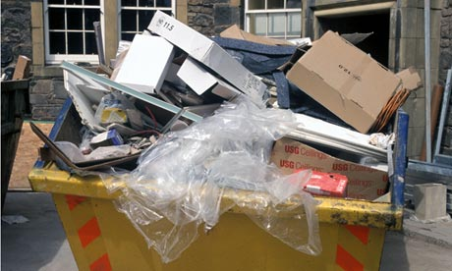

Statistic puts story into perspective and, again, emphasises seriousness.

Rhetorical question leads into the article; it makes the reader curious.

|  |
| --- |
| **Waste crime: Britain's war on illegal dumping**  **There are more than 1,000 illegal waste sites in**  **Britain, causing huge pollution and ruining**  **people's lives. Are the authorities doing enough**  **about the problem?** |

Image is bright, colourful and vivid, giving a clear illustration of the issue.

The image depicts illegal dumping; this picture is unpleasant and messy and, again, gives the reader a clearer picture of the issue.

**Connecting an image or headline to words / phrases from a text…**

**“Some waste crimes are just gruesome. Rutherford last year helped convict a Derbyshire woman who had been illegally disposing of clinical waste and dead pets”**

**- An example of a ‘waste crime’ – a serious one, too**

**“a rubbish-strewn Derbyshire farmyard”**

**“87 known illegal waste disposal sites”**

**“half-filled skips and trailers of fresh builder's rubble”**

**-Examples of these kind of environments – they do exist!**

**“Earlier this year, four waste bosses operating six illegal waste sites in Lancashire were sentenced to jail terms of up to 18 months”**

**-Supports the idea of a ‘war’ – something’s being done**