**Lesson 1 – Unit 1 GCSE English Language Revision**

|  |
| --- |
| Learning Objective**: Can I read to retrieve key information, and explain this information in detail?** (Key words: **Summarise, Explain, Perceptive)** |

We are going to work this week on retrieving information from a text and explaining it. You need to show you can do this in your own words, using short quotes to support your answer. Essentially, you need to show you’ve fully understood a short piece of writing.

**Lesson Focus -** To retrieve information and explain it to show you’ve fully understood a text (usually a newspaper article)

**You have 2 MINUTES to read this article.**

**IN PAIRS**

**Now the text is covered, summarise the ‘gist’ of the article in 4-5 bullet points.**

**What do you learn from the article about what Piers Sellers is doing and why he wants to do it? (8 marks)**

**Band 4: ‘perceptive, detailed’ (7 – 8 marks)**

* offers **evidence** that the article is **fully understood**
* shows a **detailed engagement** with the text
* makes **perceptive connections** and **comments** about **people, places and events**
* offers appropriate quotations or references to support understanding

**Band 3: ‘clear, relevant’ (5-6 marks)**

* shows clear evidence that the text is understood
* shows clear engagement with the text
* may interpret the text and make connections between people, places and events
* offers relevant quotations or references to support understanding

**”**

**Band 4: ‘perceptive, detailed’**

**Firstly, learn that Piers Sellers is going to be ‘the last Briton to fly on a space shuttle’. He is going to travel to the International Space Station and back again, a journey of 4.9 million miles. Sellers plans to take a piece of wood from the apple tree that inspired Sir Isaac Newton to come up with the theory of gravitation. The idea to take the wood is described as ‘a fun thing’, and Sellers jokes about Isaac Newton being ‘spacesick’, which shows that taking the wood is a light hearted way of increasing public awareness of Newton’s discovery.**



**USEFUL WORDS & PHRASES**

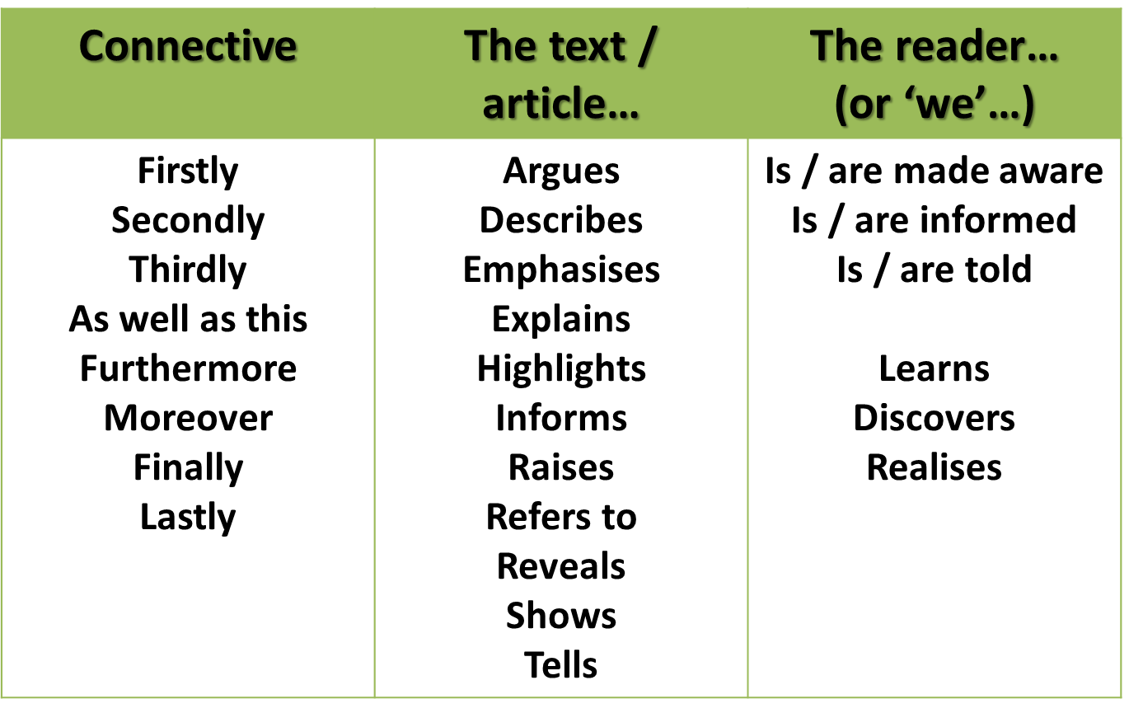

**USEFUL WORDS & PHRASES**

What do you learn from the article about what Piers Sellers is doing and why he wants to do it? (8 marks)

**Model Answer – Full Marks [8 marks]**

|  |
| --- |
| We learn that Piers Sellers is going to be ‘the last Briton to fly on a space shuttle’. He is going to travel to the International Space Station and back again, a journey of 4.9 million miles. Sellers plans to take a piece of wood from the apple tree that inspired Sir Isaac Newton to come up with the theory of gravitation. The idea to take the wood is described as ‘a fun thing’, and Sellers jokes about Isaac Newton being ‘spacesick’, which shows that taking the wood is a light hearted way of increasing public awareness of Newton’s discovery.  Sellers intends to demonstrate Newton’s laws – he says ‘it would have proved his first law of motion to be correct’. This illustrates his respect for Isaac Newton, although his joke about how it would ‘confuse Isaac’ suggests that he doesn’t take his idea entirely seriously. This shows that the text has been written to entertain, as well inform.  Keith Moore, the head librarian at the Royal Society, backs up the idea that the mission is intended to capture the public’s imagination by saying the ‘idea is that this will inspire people. You can begin to talk to school children about science’. This suggests that part of the reason for Sellers taking the piece of tree is to encourage young people to engage with science, and to show that it can be fun and interesting.  Seller is also undertaking the mission to help the Royal Society celebrate their 350th anniversary. The article tells us that Sellers approached the Royal Society to ask to ‘take something up’ into space. This suggests that he wants the Society to be involved in the mission, possibly because Isaac Newton was once president of it. |